# PK8200 – Risk influence modelling

## Warm up problem

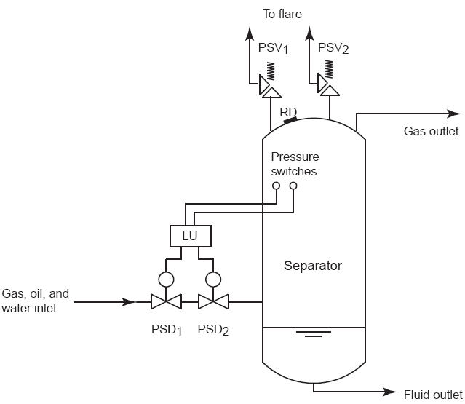

Figure 1 Separator

Consider the separator in Figure 1. To control the pressure in the separator two pressure switches (PSW1 and PSW2) are installed in parallel, and voted by a logic unit (LU). The logic unit gives signal to pilot valves activating the two process shutdown valves (PSD1 and PSD2) also in parallel from a safety point of view. (The pilot valves could be seen as a part of the PSD-valves in this problem). If the PSD system fails to shut down the inlet to the separator upon e.g., a blockage of the gas outlet, the pressure relief valves (PSV1 and PSV2) will be opened at a pressure set-point somewhat above the set-point for the PSD system. (A pressure relief valve has no external actuator, it will be opened by the pressure in the vessel directly. If one of the PSVs is opened, the gas is sent to flare.) The two PSVs are also redundant from a safety point of view. Finally if both the PSVs also fail to open, the rupture disk (RD) will open at an even higher pressure level (last barrier before rupture of the entire vessel). The possible end consequences upon the initiating event “Gas outlet blocked” are shown in Table 1:

Table 1 End consequences (all amounts in NOK)

|  |  |  |
| --- | --- | --- |
| End consequence | PLL | EC = Expected cost (mat dam , prod. & environmental loss) |
| ➀ Controlled shutdown, no gas “lost” | 0 | 0 |
| ➁ Gas relieved to flare | 0.001 | 1 000 000 |
| ➂ Gas flowing out of rupture disc | 0.2 | 10 000 000 |
| ➃ Rupture or explosion of separator | 5 | 1 000 000 000 |

Both the PSVs and the PSD-valves are periodically tested. The relevant reliability data, e.g., the rate of dangerous undetected failures (DU), the common cause factor (*β* ) etc are given in Table 2.

Table 2 Basic reliability data

|  |  |  |
| --- | --- | --- |
| Parameter Value | | Comment |
| **PSW | 1.00E-06 | Rate of DU failures, pressure switches (hrs-1) |
| **PSD | 5.00E-06 | Rate of DU failures, process shutdown valves (hrs-1) |
| *qLU* | 1.00E-04 | Constant failure probability, logic unit |
| **PSW | 4380 | Test interval, pressure switches (hrs) |
| **PSD | 8760 | Test interval, process shutdown valves (hrs) |
| **PSW | 10 % | -factor pressure switches |
| **PSD | 3 % | -factor process shutdown valves |
| **Demand | 3E-03 | Frequency of gas outlet blockage (hrs-1) |
| **PSV | 8E-06 | Rate of DU failures, pressure relief valves (hrs-1) |
| *qRD* | E-03 | Constant failure probability, rupture disc |
| **PSV | 8760 | Test interval, pressure relief valves (hrs) |
| **PSV | 10 % | -factor pressure relief valves |

1. Establish a fault tree for the PSD system, and find the minimal cut-sets. Define the TOP event in a manner like “PSD system fails to shut-down upon a high pressure in the vessel”. Hint: Use an extra basic event for each common cause failure you include.
2. Establish a fault tree for the two PSVs, and find the minimal cut-sets. Define the TOP event in a manner like “PSV system fails to release pressure, i.e., fail to send gas to the flare”. Hint: Use an extra basic event for each common cause failure you include.
3. Find the TOP-event probability (probability of failure on demand) for the two fault trees in problem a) and b) based on the reliability data in Table 2 where you also include common cause failures. Hint 1: Failure probability (PFD) of a component being periodically tested is *λτ*/2, PFD for a parallel structure of independent components (*λτ*)2/3
4. Establish an event tree where you use “Gas outlet blocked” as initiating event. Describe how you include the fault tree in your model.
5. Find the frequencies for all end consequences in Table 1. Also find the PLL contribution, and the expected costs related to this scenario.

For more information regarding PFD for safety instrumented systems, have a look in summary notes for chapter 13 in the safety and reliability book. For common cause failure modelling, see chapter 8.