Exercise 1: Establish a mathematical model of the RLC system shown in the Fig. 1 and express it in the form of transfer function.
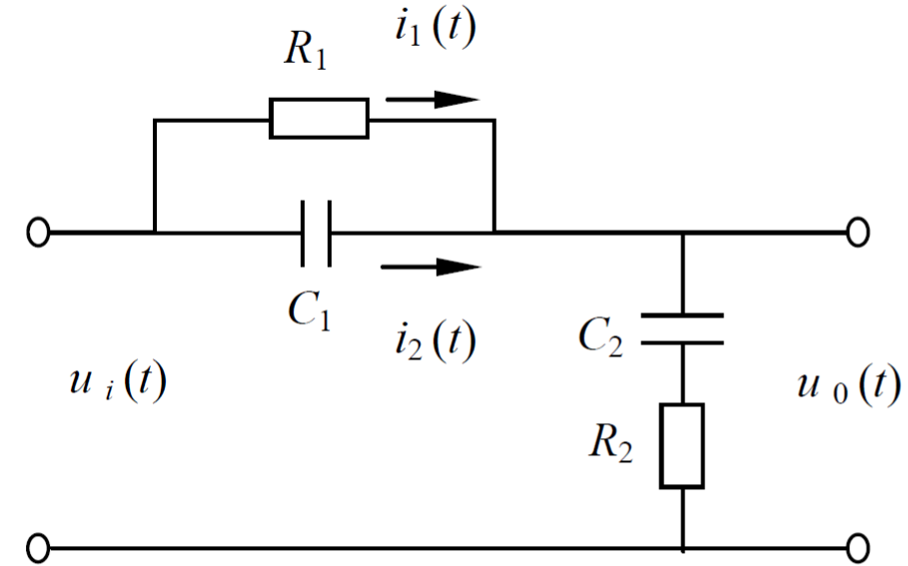
Fig. 1 RLC system structure

Exercise 2: The three-phase flow equipment at Cranfield University aims to provide controllable and measurable flow rates of water, oil, and air for pressurized systems. The industrial process is shown in Fig. 2 and can be used to achieve fault diagnosis and health monitoring tasks. The dataset contains 24 variables collected by sensors and six types of faults based on various operating conditions. The detailed content can be found in reference [1]. The specific methods for implementing fault diagnosis tasks based on system modeling methods are as follows. Firstly, divide the dataset into training and test sets and use data preprocessing methods. Then, relying on the specific modeling methods in Chapters 2 and 3, achieve the fault diagnosis task with the input variable information. Finally, the trained model is applied to the test set to obtain diagnostic performance indicators.
[1] Ruiz-Cárcel C, Cao Y, Mba D, et al. Statistical process monitoring of a multiphase flow facility. Control Engineering Practice, 2015, 42: 74-88.
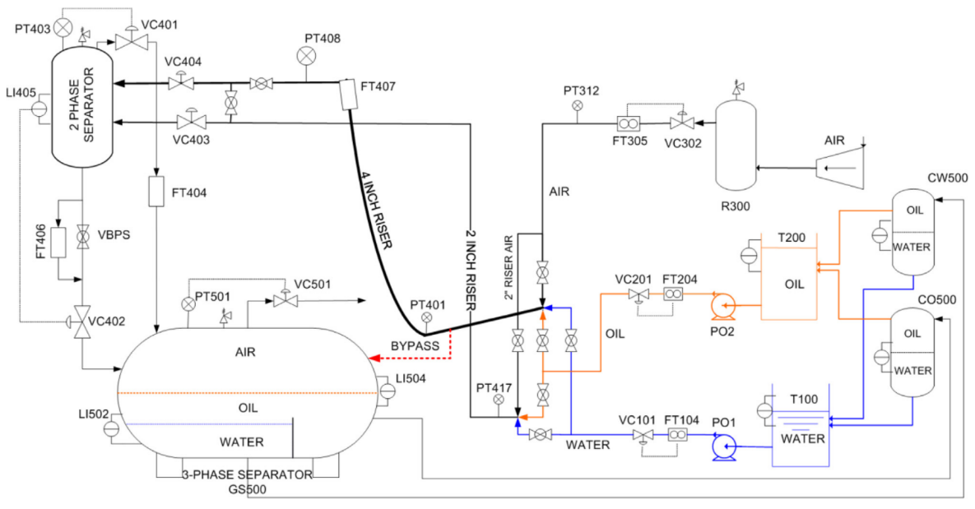
Fig. 2 Sketch of the three-phase flow facility

Exercise 3: The aircraft turbofan engine dataset, provided by NASA Ames Research Center, consists of four different working conditions, is used as the case study for the system modeling for the RUL prediction. The training sets contain the whole life cycle evolution data of the aircraft turbofan engine from health to failure. On the other hand, the testing sets contain the initial evolution data for some time. Furthermore, the whole dataset contains multivariate time series of 26 variables, including operational setting parameters and sensor measurement data during the working process. The details of the dataset can be referred to the literature [2]. The architecture diagram of the aircraft turbofan engine can be shown in Fig. 3. The historical training data set can be used to model aircraft turbofan engines. It should be noted that the research problem is to use the initial evolution data provided by the testing sets to predict the remaining useful life at the last moment of the period. For specific modeling approaches, please refer to the content in Chapters 2 and 3 of the lecture.
[2] Saxena A, Goebel K, Simon D, Eklund N. Damage propagation modeling for aircraft engine run-to-failure simulation. 2008 international conference on prognostics and health management. IEEE; 2008, p. 1–9.
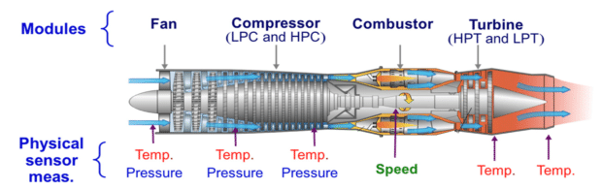
Fig. 3 The architecture diagram of the aircraft turbofan engine

Exercise 4: Given the equation of the control system as x=Ax+Bu, where:
Design the state feedback: u=-Kx to achieve the desired closed-loop poles: p₁=−1，p₂=−2. Compare the step responses with and without the pole placement.

